# CS 255 Business Requirements Document Template

## System Components and Design

### Purpose

*What is the purpose of this project? Who is the client and what do they want their system to be able to do?*

* The client, DrivePass, offers driving classes for student drivers and is seeking to create a connected online platform for their business
* The system should support seamless online access for data viewing/ability to download reports for offline use.
* The system should allow customers to book, cancel, and modify their lessons

### System Background

*What does DriverPass want the system to do? What is the problem they want to fix? What are the different components needed for this system?*

* DriverPass wants a system that provides a complete solution for scheduling driving lessons, taking online practice exams, and data tracking.
* The key problem is that many students fail their DMV driving tests due to inadequate training and preparation.
* The components of this system should include an online portal for customers, role-based user access, lesson scheduling, and data tracking.
* The system should include robust data security measures to protect customer and company data.
* The system needs to integrate with the DMV for updates to ensure practice exams and training content are current.

### Objectives and Goals

*What should this system be able to do when it is completed? What measurable tasks need to be included in the system design to achieve this?*

* The system should allow customers to register, schedule, and cancel driving lessons independently through an online platform.
* The system should allow DriverPass employees with tools to manage reservations and track lesson progress.
* The system needs to offer role-based access control to ensure only authorized users can modify accounts and access sensitive customer information.
* The system should provide tracking and reporting features that log user actions.
* The system should allow administrators to enable or disable specific training packages.
* The system must integrate with external DMV notifications to ensure content is still accurate.

## Requirements

### Nonfunctional Requirements

#### Performance Requirements

*What environments (web-based, application, etc.) does this system need to run in? How fast should the system run? How often should the system be updated?*

* The system must be a web-based application, accessible on both a PC and a mobile device.
* The system must have a reasonable response time when responding to user actions like logging in, viewing test scores, or scheduling a lesson.
* The system will need to be updated whenever there are new updates on rules and policies from the DMV.

#### Platform Constraints

*What platforms (Windows, Unix, etc.) should the system run on? Does the back end require any tools, such as a database, to support this application?*

* The system should run on all major operating systems, including Windows, Linux, Android, macOS, and iOS.
* The back end must support cloud hosting to ensure scalability and minimize infrastructure on premises.
* The system needs a central database to manage user appointments and the Driver’s schedule.
* The back end should integrate with DMV APIs to receive updates on rules and regulations.

#### Accuracy and Precision

*How will you distinguish between different users?* *Is the input case-sensitive? When should the system inform the admin of a problem?*

* Users will be identified through data like a unique username.
* Authentication of the usernames and passwords should be case sensitive.
* The system should alert the IT admin in real-time if there is an issue with the database or the connection to that database.

#### Adaptability

*Can you make changes to the user (add/remove/modify) without changing code? How will the system adapt to platform updates? What type of access does the IT admin need?*

* Users can be added, removed, or modified by the Owner or the IT officer through a dedicated interface that can change data directly in the database.
* The system will support API integrations to ensure seamless updates from the DMV.
* The IT officer or the Owner should be able to enable or disable specific training packages without modifying code.

#### Security

*What is required for the user to log in? How can you secure the connection or the data exchange between the client and the server? What should happen to the account if there is a “brute force” hacking attempt? What happens if the user forgets their password?*

* Users are required to log in using a unique username and a secure password.
* Because the system will be dealing with PII (Personally Identifiable Information), all data exchanges between a client device and the central database should be encrypted using the HTTPS and SSL/TLS protocols.
* If the system detects a known user has entered their password incorrectly 10 times, then the account should be temporarily locked, and an alert should be sent to the IT officer.
* The system should offer MFA (Multi-Factor Authentication) to users as an optional security measure. Actors that can access the central database directly (the Owner and IT officer) should be required to use MFA.
* The system should support a Password reset functionality that will allow users to securely reset their password if they forget it.

### Functional Requirements

*Using the information from the scenario, think about the different functions the system needs to provide. Each of your bullets should start with “The system shall . . .” For example, one functional requirement might be, “The system shall validate user credentials when logging in.”*

* The system shall allow customers to create, modify, and cancel driving lesson reservations online.
* The system shall authenticate the user with their account credentials when logging in.
* The system shall track with instructor, car, and time slot are assigned to each driving lesson.
* The system shall provide an admin interface that allows the IT officer or Owner to manage user accounts.
* The system shall generate an audit log of each appointment that tracks changes such as modifications and cancelations.
* The system shall allow the customer to purchase different training packages.
* The system shall send notifications to the customers when there are new updates from the DMV.
* The system shall allow customers to reset a forgotten password securely.

### User Interface

*What are the needs of the interface? Who are the different users for this interface? What will each user need to be able to do through the interface? How will the user interact with the interface (mobile, browser, etc.)?*

* Needs of the Interface
  + The user interface should be user friendly and accessible on both a PC and a mobile device.
  + The user interface should support role-based access, only displaying relevant information to the specific user.
  + The user interface must include test progress, reservations, and display data relevant to the user.
* Different Users of the Interface
  + Customers
  + Secretaries
  + Admins (IT Officer and Owner)
* What Each User Needs to Do:
  + Customers
    - Create, modify, and cancel reservations
    - View driving test progress
    - Reset forgotten passwords securely
    - Update personal or billing information
  + Secretaries
    - Make reservations for existing customers
    - Manage reservations via phone or in person requests
  + Admins
    - Manage user accounts
    - Update offered packages
    - View audit logs
* How Users Interact with the Interface
  + The user interface will be web-based, allowing it to be accessible on modern PCs and mobile devices.
  + Notifications and alerts will be sent via email

### Assumptions

*What things were not specifically addressed in your design above? What assumptions are you making in your design about the users or the technology they have?*

* The system assumes that all users have access to a stable internet connection.
* The system assumes that users have access to a modern internet connected device that they can use to access it.
* The system assumes that the DMV will provide timely updates via their API.
* The design of the system assumes users can reset their passwords independently without needing technical support.
* The design of the system assumes that the system will need to be scaled in the future if the business continues to grow.

### Limitations

*Any system you build will naturally have limitations. What limitations do you see in your system design? What limitations do you have as far as resources, time, budget, or technology?*

* System Design Limitations
  + Offline access is limited to viewing downloaded reports, as real time updates will require an internet connection.
  + The system uses APIs that are not directly managed by DriverPass, which may have delays or outages beyond our control.
  + The system cannot be modified by non-technical users to add or remove features. These changes will require a developer to implement them.
* Resource, Time, Budget, or Technology Limitations
  + Budget constraints may limit features like MFA initially.
  + Development time is not unlimited, which requires the prioritization of core functionality over future enhancements.
  + Dependence on a cloud service means the system is subject to their service level agreements and downtime.

### Gantt Chart

*Please include a screenshot of the GANTT chart that you created with Lucidchart. Be sure to check that it 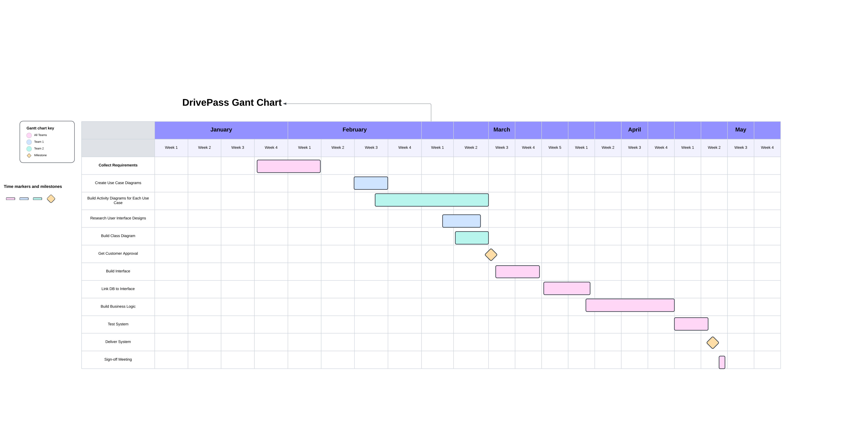meets the plan described by the characters in the interview.*